Compass and Straightedge Constructions

Definition
# Source: AI Source: Provided by: [Data Path: Persons Table -> ID Column: 1, Name_En Column: Motasem Essam] -> From: [ChatGPT] on [7/25/2026]
Compass and Straightedge Constructions are exact geometric constructions performed using only two classical Euclidean instruments:
- Compass
- Straightedge
The purpose is to construct geometric objects such as points, line segments, rays, lines, angles, perpendiculars, parallels, bisectors, triangles, and circles according to precise geometric rules.
These constructions are based on exact geometric relationships rather than approximate measurement.
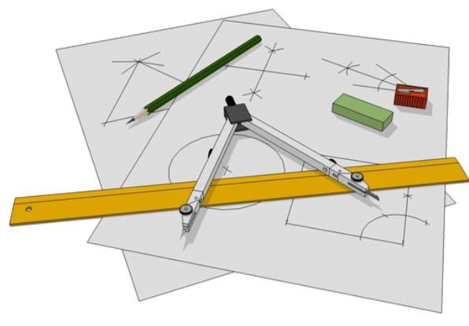
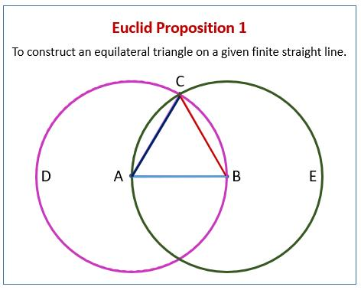
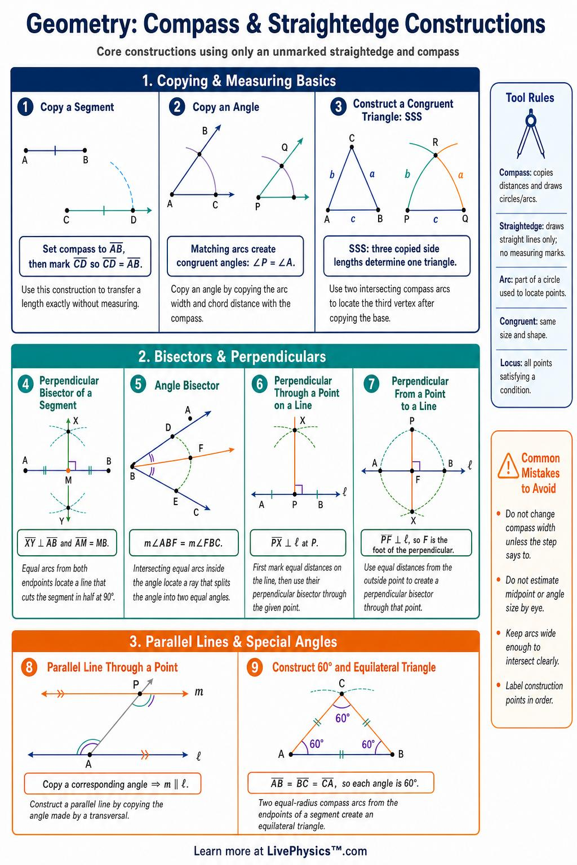
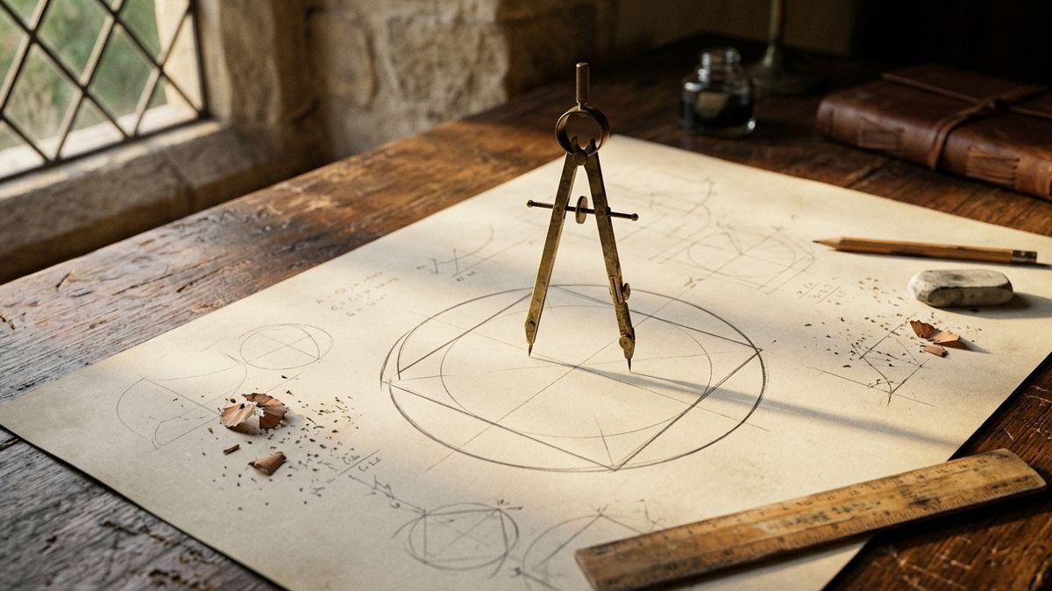
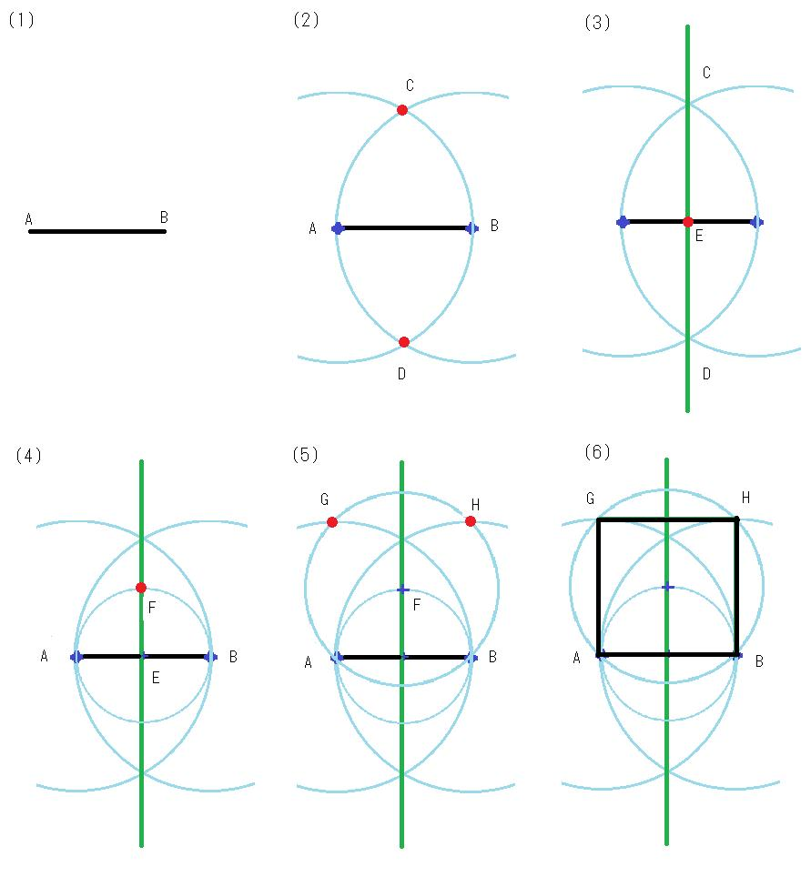
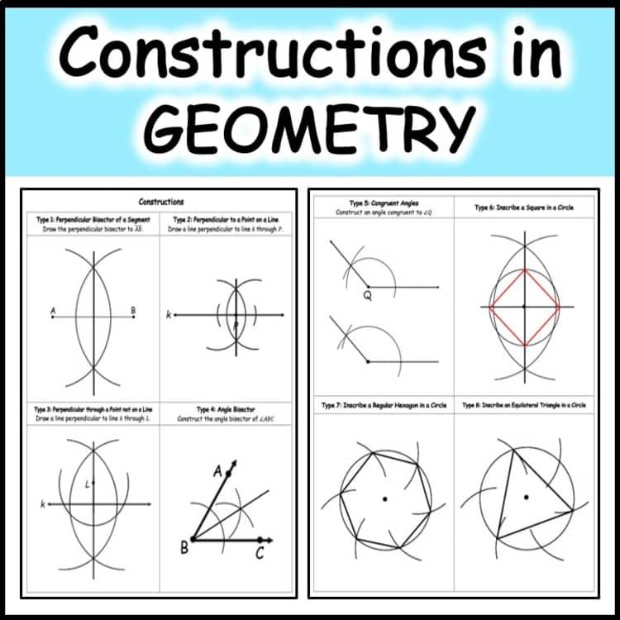
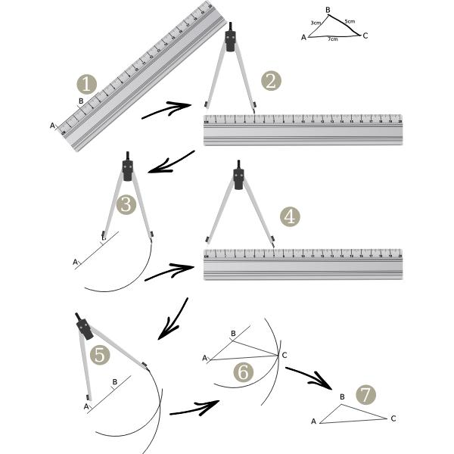

Fundamental Concept
# Source: AI Source: Provided by: [Data Path: Persons Table -> ID Column: 1, Name_En Column: Motasem Essam] -> From: [ChatGPT] on [7/25/2026]
A classical construction starts with given geometric information and uses a sequence of permitted operations with a compass and straightedge to create the required object.
The fundamental idea is:
$$\boxed{\text{Given Objects}→\text{Construction Steps}→\text{Required Object}}$$
For example, to construct the perpendicular bisector of a segment:
$$\overset{‾}{AB}→\text{Equal Arcs}→\text{Arc Intersections}→\text{Perpendicular Bisector}$$

The Two Classical Instruments

1. Straightedge
# Source: AI Source: Provided by: [Data Path: Persons Table -> ID Column: 1, Name_En Column: Motasem Essam] -> From: [ChatGPT] on [7/25/2026]
A straightedge is a tool with a straight edge used to construct straight lines.
In classical geometric construction, the straightedge is traditionally unmarked.
It can be used to:
- draw a line through two known points
- extend a line
- connect constructed points
- draw a ray
- draw a line segment
- connect intersections of arcs
It is not traditionally used for measuring distances.
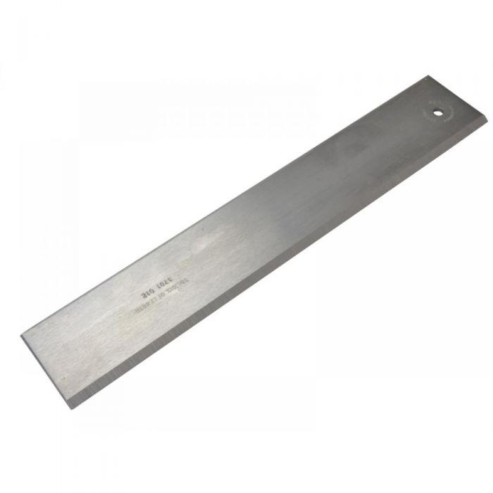
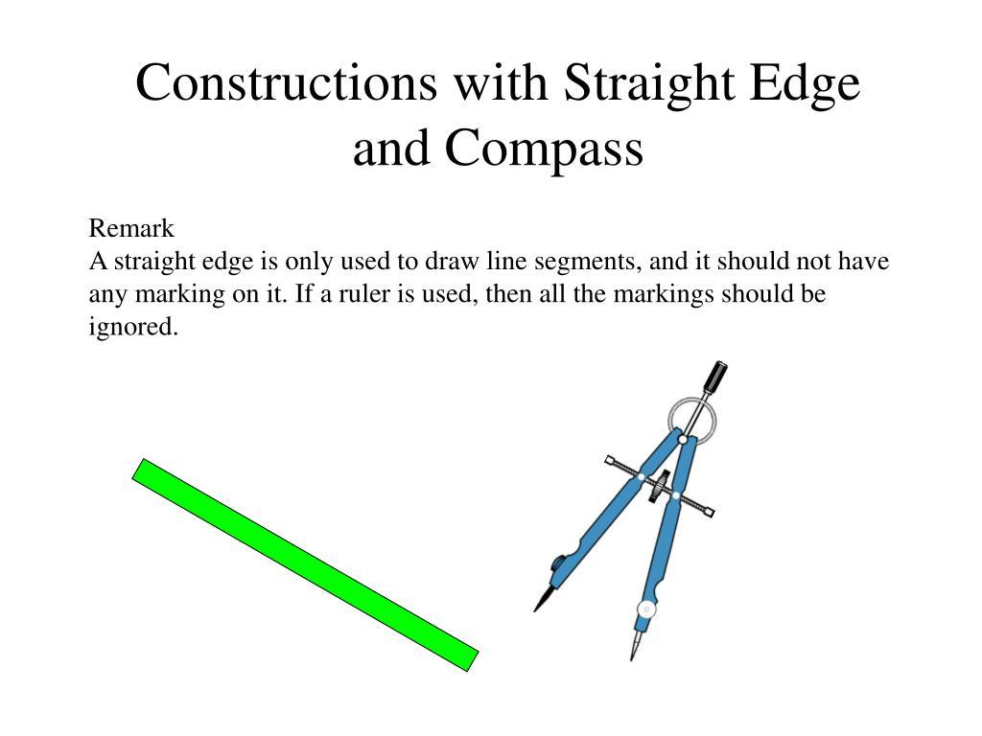
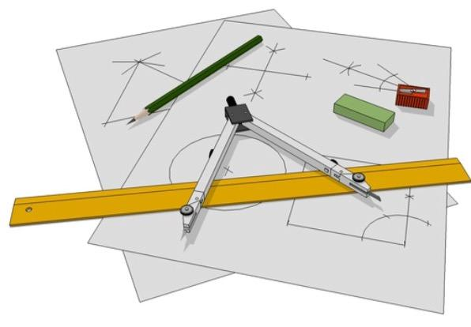

2. Compass
# Source: AI Source: Provided by: [Data Path: Persons Table -> ID Column: 1, Name_En Column: Motasem Essam] -> From: [ChatGPT] on [7/25/2026]
A compass is an instrument used to construct circles and arcs and to transfer distances.
It can be used to:
- draw a circle with a given center
- draw an arc
- transfer a length
- construct equal distances
- locate points at specified distances
- construct perpendicular bisectors
- construct angle bisectors
- copy segments and angles
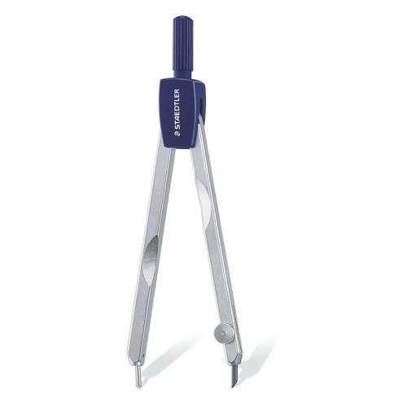
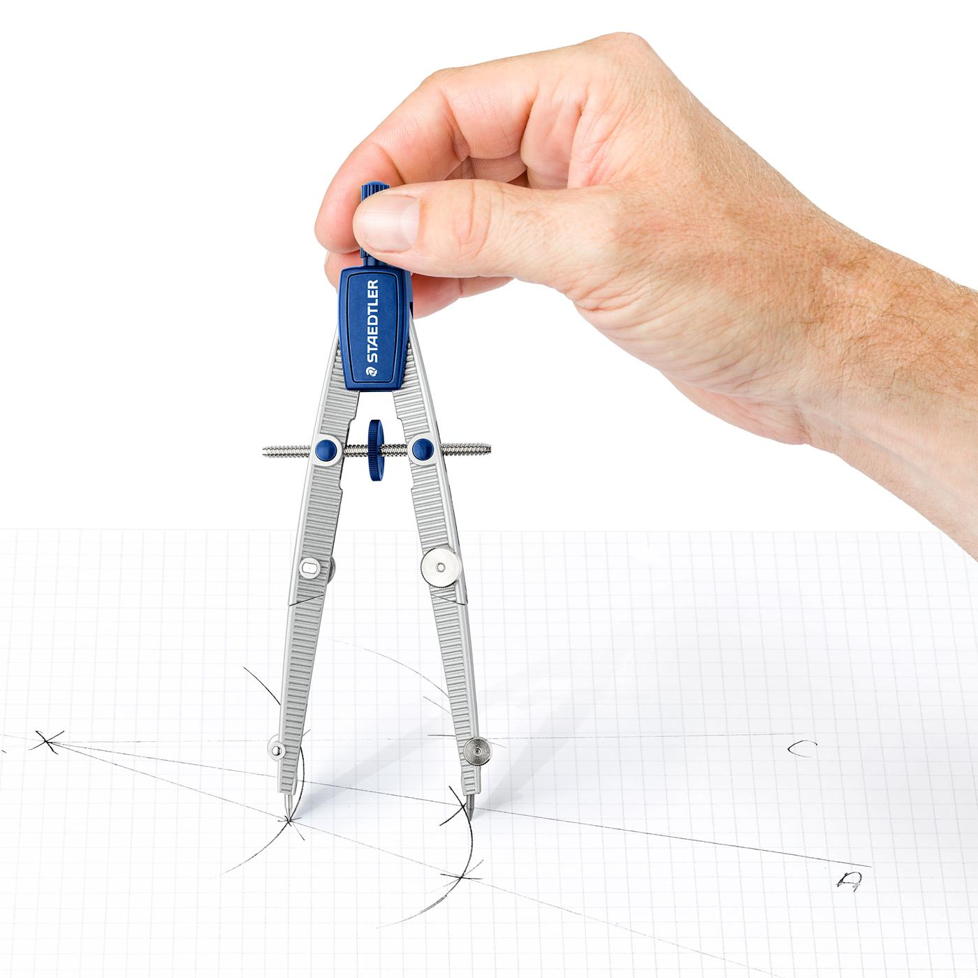
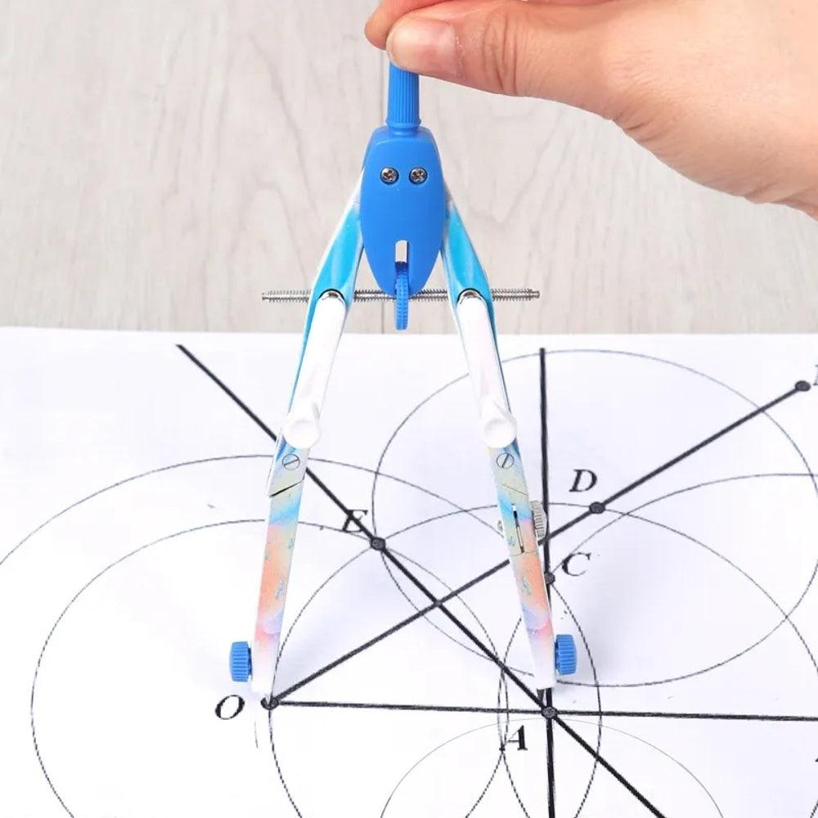

Basic Operations
# Source: AI Source: Provided by: [Data Path: Persons Table -> ID Column: 1, Name_En Column: Motasem Essam] -> From: [ChatGPT] on [7/25/2026]
Classical compass-and-straightedge construction can be understood through two fundamental operations.
Straightedge Operation
Given two constructed points $A$and $B$, draw:
$$\boxed{\overset{↔}{AB}}$$
Compass Operation
Given a center $A$and a radius determined by a known distance $AB$, construct:
$$\boxed{\text{Circle centered at }A\text{ with radius }AB}$$
or:
$$\boxed{C\left(A , AB\right)}$$
The intersections of constructed lines and circles create new points.

Fundamental Construction Types
# Source: AI Source: Provided by: [Data Path: Persons Table -> ID Column: 1, Name_En Column: Motasem Essam] -> From: [ChatGPT] on [7/25/2026]
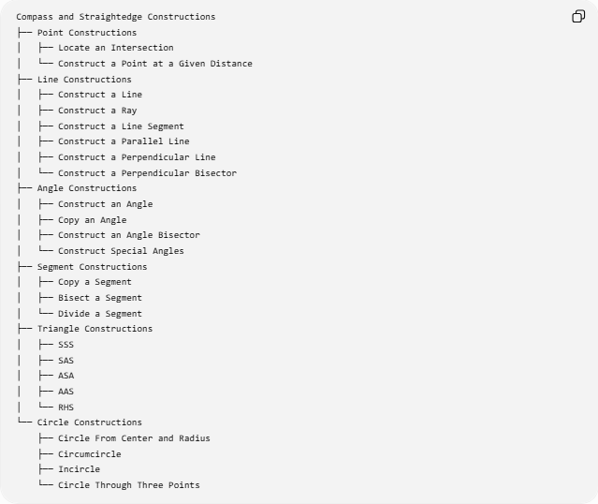
Compass and Straightedge Constructions
├── Point Constructions
│ ├── Locate an Intersection
│ └── Construct a Point at a Given Distance
├── Line Constructions
│ ├── Construct a Line
│ ├── Construct a Ray
│ ├── Construct a Line Segment
│ ├── Construct a Parallel Line
│ ├── Construct a Perpendicular Line
│ └── Construct a Perpendicular Bisector
├── Angle Constructions
│ ├── Construct an Angle
│ ├── Copy an Angle
│ ├── Construct an Angle Bisector
│ └── Construct Special Angles
├── Segment Constructions
│ ├── Copy a Segment
│ ├── Bisect a Segment
│ └── Divide a Segment
├── Triangle Constructions
│ ├── SSS
│ ├── SAS
│ ├── ASA
│ ├── AAS
│ └── RHS
└── Circle Constructions
├── Circle From Center and Radius
├── Circumcircle
├── Incircle
└── Circle Through Three Points

Common Compass and Straightedge Constructions
# Source: AI Source: Provided by: [Data Path: Persons Table -> ID Column: 1, Name_En Column: Motasem Essam] -> From: [ChatGPT] on [7/25/2026]
1. Constructing a Line Segment
Given two points $A$and $B$, use the straightedge to connect them:
$$\boxed{\overset{‾}{AB}}$$
2. Copying a Line Segment
Given $\overset{‾}{AB}$, use the compass to transfer its length to another location.
If the new segment is $\overset{‾}{CD}$:
$$\boxed{CD=AB}$$
3. Constructing a Perpendicular Bisector
Given $\overset{‾}{AB}$:
- Draw equal-radius arcs centered at $A$and $B$.
- Let the arcs intersect at $P$and $Q$.
- Draw $PQ$.
Then:
$$\boxed{PQ⊥AB}$$
and:
$$\boxed{AM=MB}$$
where $M$is the intersection of $PQ$and $AB$.
4. Constructing an Angle Bisector
Given $∠ABC$:
- Draw an arc centered at $B$.
- Let it intersect the two sides at $P$and $Q$.
- Draw equal arcs centered at $P$and $Q$.
- Connect $B$to their intersection point $D$.
Then:
$$\boxed{∠ABD=∠DBC}$$
5. Constructing a Perpendicular Line
Given a line $l$and a point $P$, construct a line $m$such that:
$$\boxed{m⊥l}$$
Therefore:
$$\boxed{∠\left(m , l\right)={90}^{∘}}$$
6. Constructing a Parallel Line
Given a line $l$and a point $P$outside it, construct $m$through $P$such that:
$$\boxed{m∥l}$$
This can be accomplished by copying an appropriate angle or using perpendicular constructions.

Constructing Special Angles
# Source: AI Source: Provided by: [Data Path: Persons Table -> ID Column: 1, Name_En Column: Motasem Essam] -> From: [ChatGPT] on [7/25/2026]
Compass and straightedge constructions can produce several important angles.
$${60}^{∘}$$
A ${60}^{∘}$angle can be constructed using an equilateral triangle.
$$\boxed{{60}^{∘}}$$
$${90}^{∘}$$
Construct a perpendicular line:
$$\boxed{{90}^{∘}}$$
$${30}^{∘}$$
Bisect a ${60}^{∘}$angle:
$$\boxed{{30}^{∘}=\frac{{60}^{∘}}{2}}$$
$${45}^{∘}$$
Bisect a ${90}^{∘}$angle:
$$\boxed{{45}^{∘}=\frac{{90}^{∘}}{2}}$$
Repeated bisection can produce:
$${90}^{∘}→{45}^{∘}→{22.5}^{∘}→{11.25}^{∘}$$

Constructing a Triangle
# Source: AI Source: Provided by: [Data Path: Persons Table -> ID Column: 1, Name_En Column: Motasem Essam] -> From: [ChatGPT] on [7/25/2026]
Triangles can be constructed from different combinations of given information.
SSS — Side-Side-Side
Three side lengths are given:
$$AB, BC, CA$$
Use circles centered at the endpoints to locate the third vertex.
SAS — Side-Angle-Side
Two sides and their included angle are given.
ASA — Angle-Side-Angle
Two angles and their included side are given.
AAS — Angle-Angle-Side
Two angles and a non-included side are given.
RHS — Right Angle-Hypotenuse-Side
A right angle, hypotenuse, and one side are given.
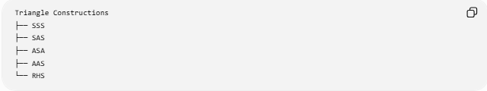
Triangle Constructions
├── SSS
├── SAS
├── ASA
├── AAS
└── RHS

Constructing Circles
# Source: AI Source: Provided by: [Data Path: Persons Table -> ID Column: 1, Name_En Column: Motasem Essam] -> From: [ChatGPT] on [7/25/2026]
A compass can construct a circle when its center and radius are known.
Given center $O$and radius $r$:
$$\boxed{C\left(O , r\right)}$$
The circle consists of all points $P$satisfying:
$$\boxed{OP=r}$$
A compass is also used in constructing:
- circumcircles
- incircles
- circles through three points
- tangent constructions
- intersections of circles

Construction by Intersections
# Source: AI Source: Provided by: [Data Path: Persons Table -> ID Column: 1, Name_En Column: Motasem Essam] -> From: [ChatGPT] on [7/25/2026]
A major principle of compass-and-straightedge construction is creating new points through intersections.
Line-Line Intersection
Two constructed lines can intersect at a point:
$$l_{1}∩l_{2}=P$$
Line-Circle Intersection
A line and circle can intersect at one or two points:
$$l∩C=\left\{P , Q\right\}$$
Circle-Circle Intersection
Two circles can intersect at:
$$C_{1}∩C_{2}=\left\{P , Q\right\}$$
These intersection points often become the key points used in later construction steps.

Construction vs Measurement
# Source: AI Source: Provided by: [Data Path: Persons Table -> ID Column: 1, Name_En Column: Motasem Essam] -> From: [ChatGPT] on [7/25/2026]
Compass-and-straightedge construction is different from ordinary measurement.
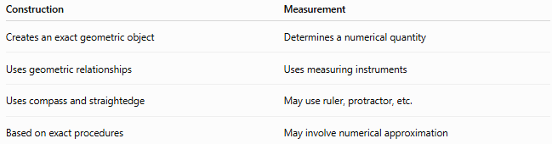
Construction | Measurement
Creates an exact geometric object | Determines a numerical quantity
Uses geometric relationships | Uses measuring instruments
Uses compass and straightedge | May use ruler, protractor, etc.
Based on exact procedures | May involve numerical approximation
For example, instead of measuring an angle with a protractor, a construction can create an exact ${60}^{∘}$angle using a compass and straightedge.

Construction vs Drawing
# Source: AI Source: Provided by: [Data Path: Persons Table -> ID Column: 1, Name_En Column: Motasem Essam] -> From: [ChatGPT] on [7/25/2026]
An ordinary drawing may be approximate.
A geometric construction must follow a defined sequence of exact operations.
For example:
Approximate drawing:
Draw something that looks like a perpendicular line.
Geometric construction:
Construct a perpendicular using equal-radius arcs and prove that the resulting line forms a ${90}^{∘}$angle.
Therefore:
$$\boxed{\text{Construction}≠\text{Approximate Drawing}}$$

Construction and Proof
# Source: AI Source: Provided by: [Data Path: Persons Table -> ID Column: 1, Name_En Column: Motasem Essam] -> From: [ChatGPT] on [7/25/2026]
A construction explains how an object can be created.
A proof explains why the construction produces the required object.
For example:
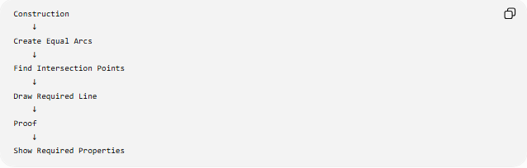
Construction
↓
Create Equal Arcs
↓
Find Intersection Points
↓
Draw Required Line
↓
Proof
↓
Show Required Properties
For an angle bisector:
$$△BPD≅△BQD$$
therefore:
$$∠PBD=∠DBQ$$
which proves that the constructed ray bisects the angle.

Exactness
# Source: AI Source: Provided by: [Data Path: Persons Table -> ID Column: 1, Name_En Column: Motasem Essam] -> From: [ChatGPT] on [7/25/2026]
Classical constructions aim to produce objects satisfying exact mathematical conditions.
For example, a constructed perpendicular satisfies:
$$\boxed{∠={90}^{∘}}$$
A constructed angle bisector satisfies:
$$\boxed{θ_{1}=θ_{2}}$$
A constructed perpendicular bisector satisfies:
$$\boxed{AM=MB}$$
and:
$$\boxed{PM⊥AB}$$

What the Straightedge and Compass Cannot Do Directly
# Source: AI Source: Provided by: [Data Path: Persons Table -> ID Column: 1, Name_En Column: Motasem Essam] -> From: [ChatGPT] on [7/25/2026]
The classical construction rules do not allow:
- reading measurements from a ruler
- measuring an angle with a protractor
- marking arbitrary numerical distances directly
- using a marked straightedge to transfer measurements
The classical straightedge is unmarked.
The compass transfers distances through geometric constructions rather than numerical readings.

Classical Construction Hierarchy
# Source: AI Source: Provided by: [Data Path: Persons Table -> ID Column: 1, Name_En Column: Motasem Essam] -> From: [ChatGPT] on [7/25/2026]
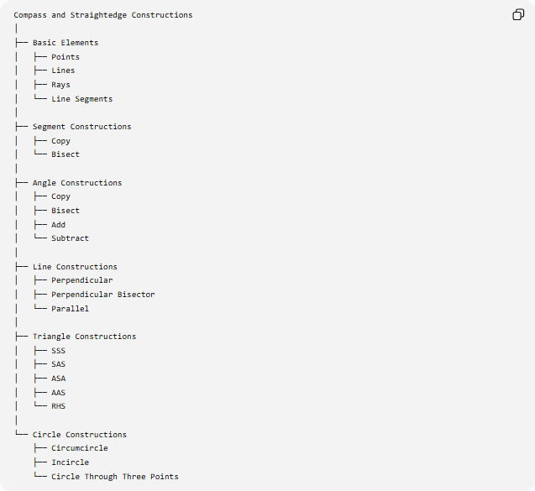
Compass and Straightedge Constructions
│
├── Basic Elements
│ ├── Points
│ ├── Lines
│ ├── Rays
│ └── Line Segments
│
├── Segment Constructions
│ ├── Copy
│ └── Bisect
│
├── Angle Constructions
│ ├── Copy
│ ├── Bisect
│ ├── Add
│ └── Subtract
│
├── Line Constructions
│ ├── Perpendicular
│ ├── Perpendicular Bisector
│ └── Parallel
│
├── Triangle Constructions
│ ├── SSS
│ ├── SAS
│ ├── ASA
│ ├── AAS
│ └── RHS
│
└── Circle Constructions
├── Circumcircle
├── Incircle
└── Circle Through Three Points

Important Relationships
# Source: AI Source: Provided by: [Data Path: Persons Table -> ID Column: 1, Name_En Column: Motasem Essam] -> From: [ChatGPT] on [7/25/2026]
Many constructions are built from simpler constructions:
$$\boxed{\text{Perpendicular Bisector}=\text{Equal Arcs}+\text{Line Construction}} \\ \boxed{\text{Angle Bisector}=\text{Equal Arcs}+\text{Line Construction}} \\ \boxed{\text{Parallel Line}=\text{Angle Copying}} \\ \boxed{\text{Special Angles}=\text{Basic Constructions}+\text{Bisection/Combination}}$$

Key Points
# Source: AI Source: Provided by: [Data Path: Persons Table -> ID Column: 1, Name_En Column: Motasem Essam] -> From: [ChatGPT] on [7/25/2026]
- Compass and straightedge constructions are exact Euclidean constructions.
- The two classical instruments are an unmarked straightedge and a compass.
- The straightedge constructs straight lines.
- The compass constructs circles, arcs, and transfers distances.
- New points are frequently obtained from intersections of lines and circles.
- Common constructions include:
  - line segments
  - rays
  - lines
  - parallel lines
  - perpendicular lines
  - perpendicular bisectors
  - angle bisectors
  - special angles
  - triangles
  - circles
- A construction describes how to create a geometric object.
- A proof explains why the construction works.
- Exact construction is different from approximate drawing or numerical measurement.

Conclusion
# Source: AI Source: Provided by: [Data Path: Persons Table -> ID Column: 1, Name_En Column: Motasem Essam] -> From: [ChatGPT] on [7/25/2026]
Compass and Straightedge Constructions form the foundation of classical Euclidean geometric construction. By using only an unmarked straightedge and a compass, geometric objects can be created through a sequence of exact operations involving straight lines, circles, arcs, and their intersections. Fundamental constructions such as bisecting segments and angles, constructing perpendicular and parallel lines, and constructing triangles and circles can then be combined to create more advanced geometric figures and relationships.

